Banking Card Analytics Project — Platform Comparison
Objective 1 — Customer Segmentation (Value & Risk)
Segment the current customer base into High-Value, Medium-Value, and At-Risk tiers using credit score, income
Objective 2 — Transaction & Spending Trends
Track how customers are spending across time, category, and channel in the current period.
Objective 3 — Credit Utilization & High-Risk Accounts
Monitor credit utilization to flag over-leveraged, high-risk customers.
Objective 4 — Fraud Monitoring
Monitor fraudulent activity to surface high-risk transactions, categories, and locations — framed as near-real-time fraud surveillance.
Data source
https://www.kaggle.com/datasets/computingvictor/transactions-fraud-datasets?select=transactions_data.csv
Dataset: 5 files (3 CSV, 2 JSON), largest is transactions_data.csv at 1.17 GB and train_fraud_labels.json at 151 MB (~13M records).
Azure Synapse Analytics

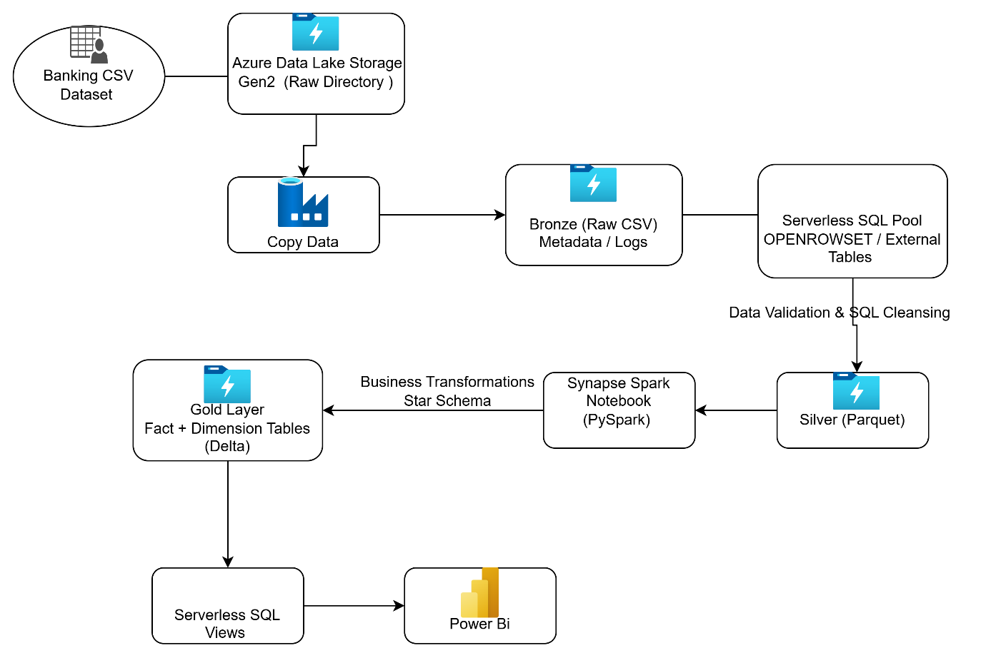

Microsoift Fabric
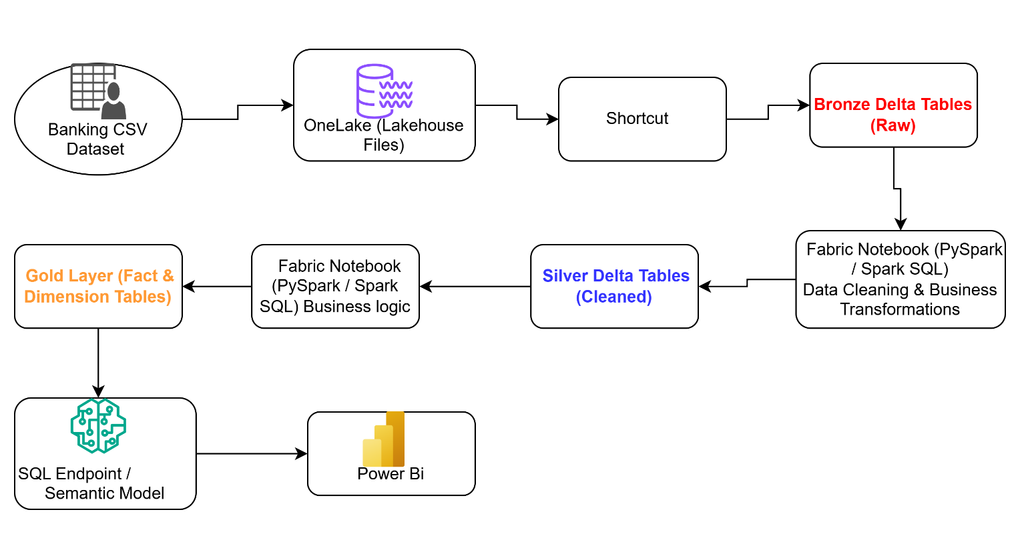

Data Bricks
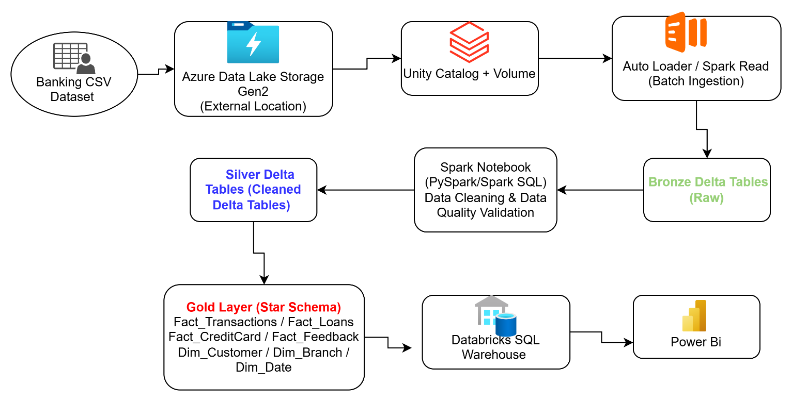

ADLS Account
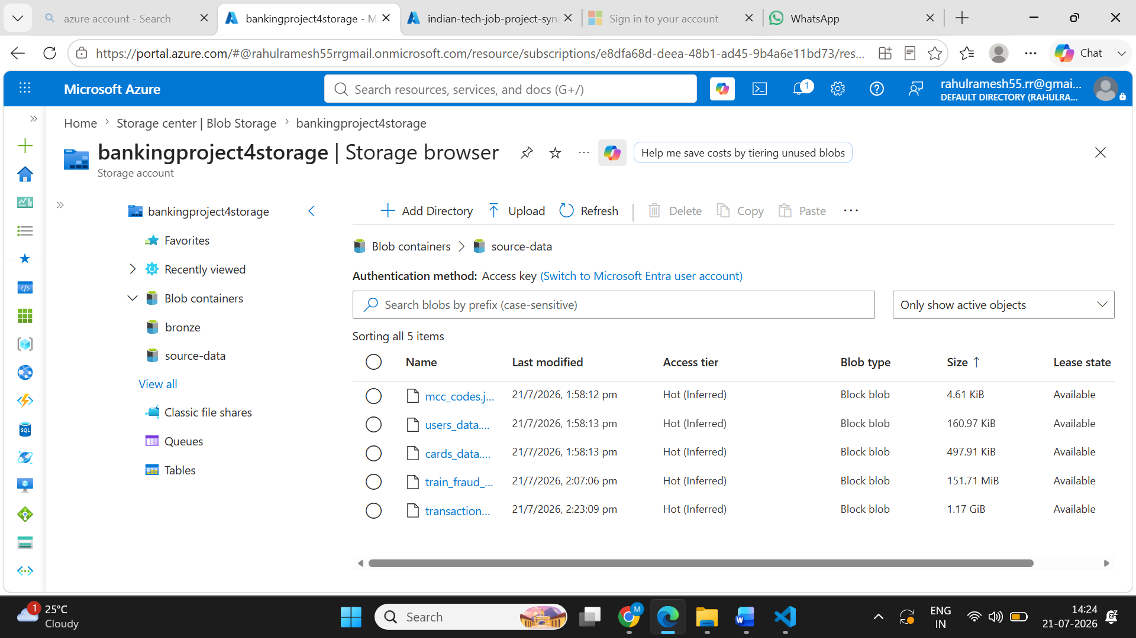
Pipe line Execution
Synapse
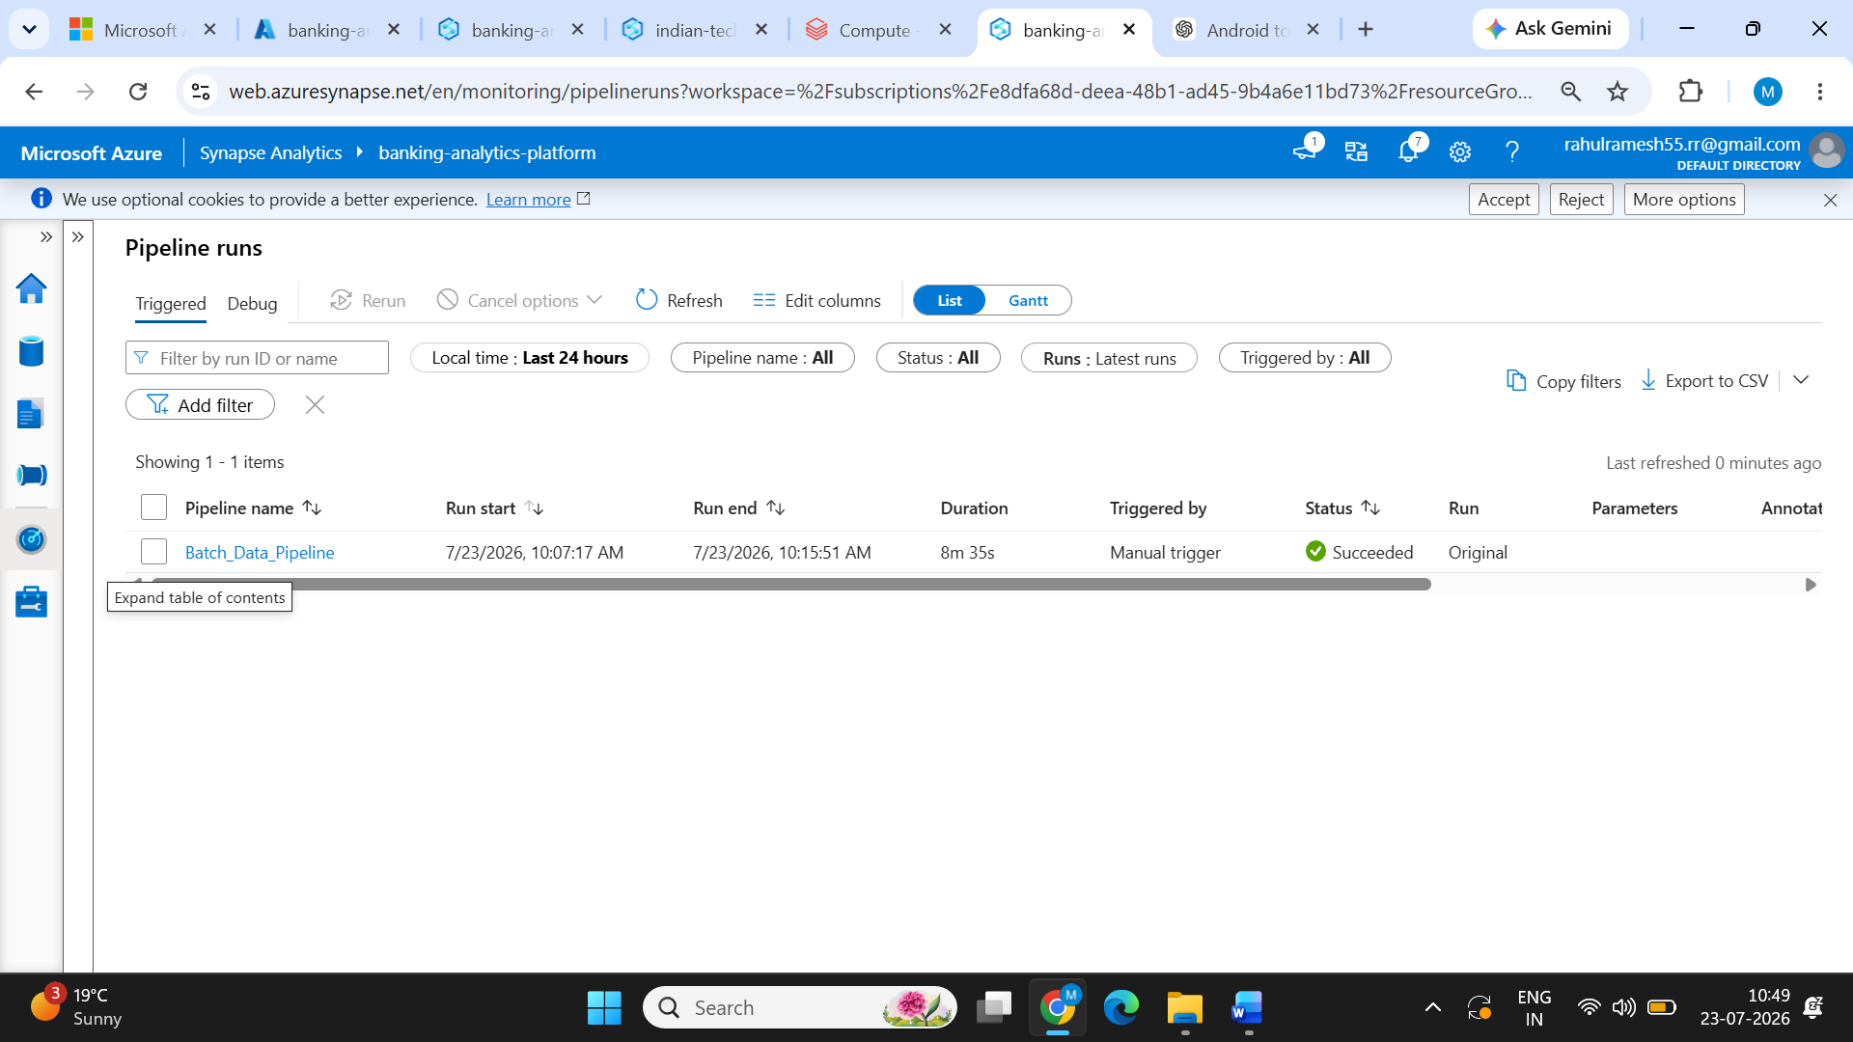

Data Bricks
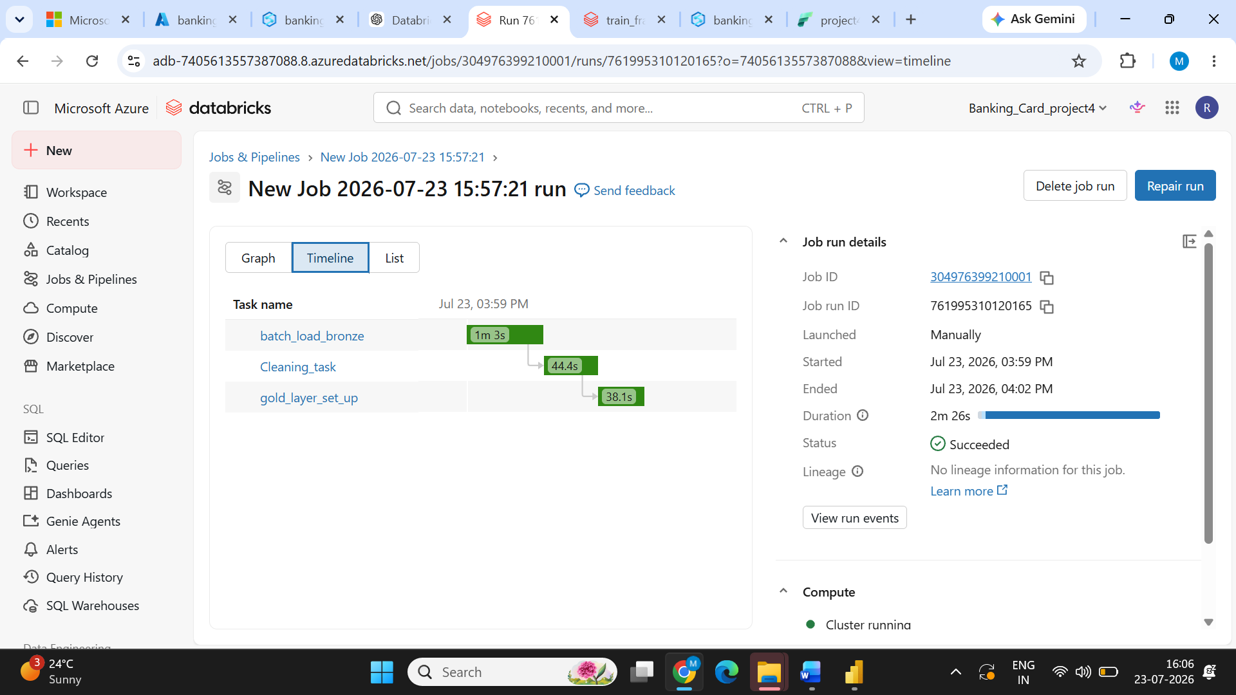

Fabric
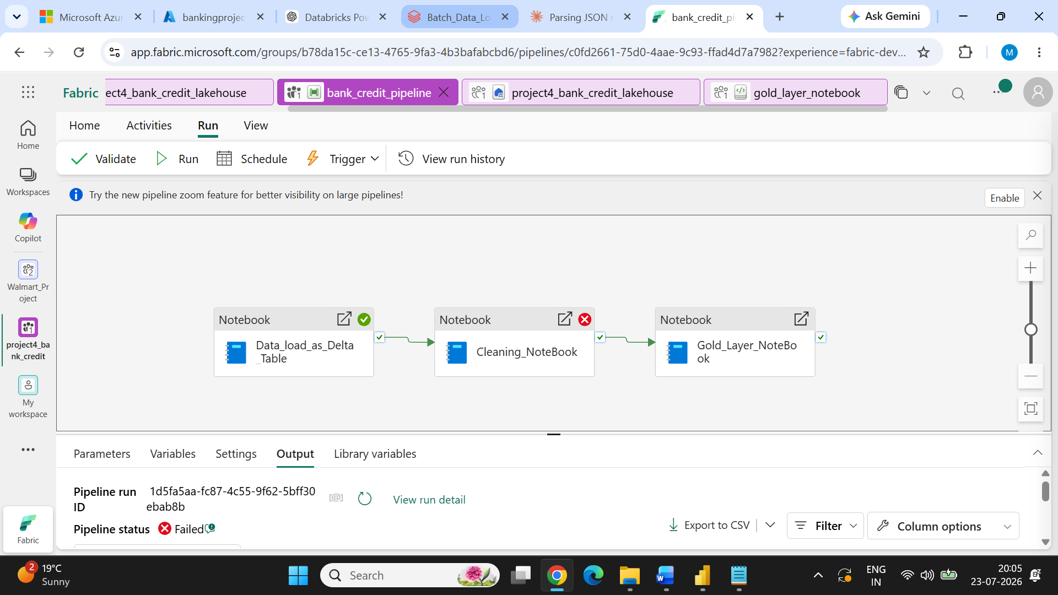

Platform Comparison — Azure Synapse vs Azure Databricks vs Microsoft Fabric

Factor | Azure Synapse Analytics | Azure Databricks | Microsoft Fabric
Data Ingestion | Copy Activity provided a straightforward way to ingest data from Azure storage. For the Kaggle dataset, additional steps were required, including uploading the required .txt file/library to support ingestion through the notebook. | Auto Loader, COPY INTO, and Python libraries provided flexible ingestion options. Kaggle API and Python requests could be used directly from the notebook. This made ingestion and initial data preparation simpler. | Notebook, Copy Activity, and OneLake Shortcuts provided multiple ingestion options. Kaggle API could be used directly in Fabric notebooks to load data into OneLake/Lakehouse. Initial ingestion was simple, although later processing was affected by capacity limitations.
Time to Build Solution | Slower in this project. Database views and SQL-based processing required separate script activities, increasing the number of pipeline components and configuration effort. | Fastest. A single notebook could handle ingestion, transformation, table creation, and interaction with ADLS through Unity Catalog. This reduced the number of separate pipeline components. | Fast. The unified workspace combined Lakehouse, Pipelines, Notebooks, and Power BI. This reduced integration and configuration effort compared with using multiple Azure services.
Query / Processing Performance | Good for SQL-heavy workloads using the serverless SQL pool. However, Spark processing had additional startup overhead, which affected the overall pipeline execution time. | Best performance in this project. The same cluster environment supported ingestion and transformation, and Databricks performed particularly well with PySpark and large nested JSON processing. | Good performance for Lakehouse and Spark workloads. However, capacity constraints affected execution consistency and prevented some complete performance comparisons.
Cost / Compute Model | Serverless SQL is based on data processed, while Spark pools incur compute costs based on resource usage and runtime. Dedicated resources provide predictable performance but may increase cost. | Uses DBUs plus underlying cloud infrastructure. Cluster size and runtime directly affect cost. Autoscaling and terminating idle clusters can help control spending, but long-running clusters can become expensive. | Uses Fabric Capacity (F SKU) shared across workloads such as Spark, Pipelines, Warehouse, and Power BI. Capacity utilization must be monitored because heavy workloads can affect availability and performance.
Processing Time — Full Pipeline | Approximately 8 min 35 sec in the tested pipeline. Performance was reliable, but Spark pool startup contributed to overall execution overhead. | Approximately 2 min 26 sec after the cluster was available. Cluster initiation was approximately 15 minutes, but actual pipeline processing was the fastest among the tested platforms. | Full pipeline execution could not be consistently completed because of Fabric capacity limitations encountered during testing.
Orchestration Support | Strong and easy to understand. Synapse Pipelines provide a rich activity library, triggers, scheduling, monitoring, and integration with notebooks and other Azure services. | Powerful but more engineering-oriented. Databricks Workflows are effective for notebook and job orchestration, but workflows can become more complex when several external activities and services are involved. | Easy and integrated. Fabric Data Factory pipelines provide drag-and-drop orchestration with scheduling, monitoring, notebook execution, and Dataflow integration in the same environment.
CI/CD Integration | Supports Git and Azure DevOps integration, but configuration and permissions can require additional setup. | Strong CI/CD experience through Git integration, Databricks Repos, and Azure DevOps/GitHub workflows. The notebook-based development model works well with version control. | Good native integration with GitHub/Azure DevOps and deployment pipelines. The integrated workspace makes promotion of Fabric artifacts easier, although some artifact types and deployment scenarios require platform-specific considerations.
BI / Power BI Integration | Strong integration with Power BI through Synapse SQL endpoints. Suitable when Power BI consumes curated SQL-based analytical data. | Power BI connects well through SQL Warehouse and Delta-based architectures. Directly connecting reports to interactive clusters can introduce cost and operational challenges, so SQL Warehouse is generally more practical for BI workloads. | Best integrated Power BI experience. Direct Lake, Lakehouse, and Warehouse integration reduce the need for traditional data import and provide a more unified analytics-to-reporting workflow.
Ease of Solution Development | Moderate. SQL-focused users may find the environment comfortable, but combining pipelines, Spark pools, SQL scripts, and linked services adds complexity. | Easy for data engineers familiar with Python and PySpark. Notebook-first development reduced development time in this project. Unity Catalog External Locations also made storage access reusable. | Easiest for an end-to-end analytics solution. Lakehouse, Pipelines, Notebooks, SQL, and Power BI are available in one platform. However, capacity-related issues affected the practical development experience in this project.
Code Assistance | Copilot capabilities are available in the broader Microsoft ecosystem, but the experience was less mature/available in this project environment. Access was also limited by the student account used for testing. | Strongest coding assistance in this project. Databricks Assistant was useful for PySpark and SQL development and helped troubleshoot issues such as path errors and variable mismatches. | Copilot provides assistance across supported Fabric experiences, including notebooks, SQL, Dataflows, and Power BI. Availability depends on licensing and capacity configuration.
Machine Learning Support | Works well with Azure Machine Learning and Spark ML. Suitable when ML workflows are integrated with the broader Azure ecosystem. | Strongest option for advanced ML and data engineering. Provides MLflow, Spark ML, Python ecosystem support, and scalable distributed processing. | Provides an integrated Data Science experience with notebooks and ML capabilities. Convenient for analytics-focused ML but less mature than Databricks for advanced ML engineering workloads.
Technical Support | Strong Microsoft Azure support ecosystem and enterprise documentation. Suitable for organizations already invested in Azure. | Strong Databricks enterprise support combined with Azure infrastructure support. Large ecosystem of Spark and data engineering resources. | Microsoft enterprise support covers Fabric workloads and integrates with the broader Microsoft analytics ecosystem.
Migration Support | Migration is straightforward for organizations already using ADLS, Azure SQL, and other Azure services. Open formats such as Parquet and Delta improve portability. | Delta Lake and open data formats support migration flexibility. However, external storage access requires configuration through Unity Catalog, storage credentials, or External Locations. | OneLake and Delta Lake provide a unified storage architecture. Existing Microsoft workloads such as Power BI, ADLS, and Azure Data Factory can generally be integrated with relatively low migration effort.
Industry Trend / Best Fit | Strong choice for organizations heavily invested in Azure, SQL Server, and traditional enterprise data warehousing, including banking and financial services. | Strong industry adoption for large-scale data engineering, advanced analytics, AI/ML, and complex Spark workloads. Particularly suitable for organizations handling large data volumes and requiring engineering flexibility. | Rapidly growing platform for organizations using Microsoft 365, Power BI, Azure, and unified analytics. Well suited for organizations wanting an integrated Lakehouse-to-BI solution.
Cloud Storage Connection | Uses Linked Services to connect with ADLS Gen2, Blob Storage, and other Azure resources. | Uses Unity Catalog External Locations and Storage Credentials for controlled access to external ADLS storage. The setup was clean and reusable in this project. | Uses OneLake Shortcuts to access external ADLS Gen2 data without unnecessary data duplication, along with native Lakehouse storage.

